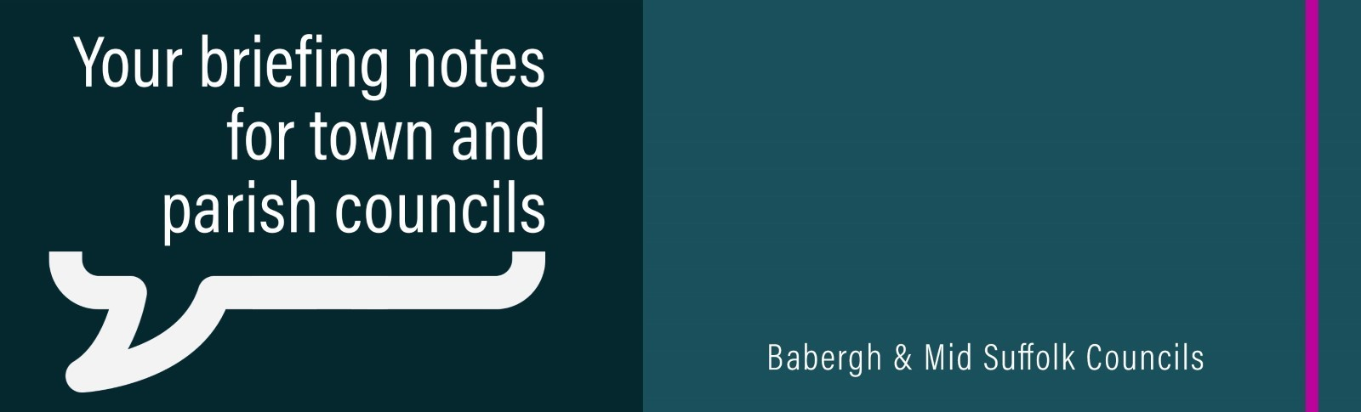

December 2023

Blueprint for districts’ development adopted by councils
Babergh and Mid Suffolk District Councils have formally adopted their Joint Local Plan - the blueprint for the districts' future development until 2037.

New unit for The Range completed at Gateway 14
A new 1.17 million square foot warehouse unveiled in Stowmarket.

Free insulation upgrades in new £2m Mid Suffolk initiative
Hundreds of people could qualify for free home insulation upgrades under the council’s new £2million initiative.

Extra £1.6m set for council home repairs and improvements
Additional funds will help clear backlog of work which mounted during Covid pandemic.

Financial aid for flood-affected properties in Suffolk
Financial support is going out to residents whose properties flooded during Storm Babet.

£1.4m to tackle criminal exploitation in Suffolk
Suffolk Public Sector Leaders have awarded £1.4m in funding to the Safer Stronger Communities Board to tackle criminal exploitation in the county.

Council urges green energy developers to listen to communities
Mid Suffolk District Council is urging developers to listen to the concerns of local communities.

Time to make our listed buildings ready for the future?
Consultation into new measures which would streamline sensitive energy efficiency upgrades.

Call for land to support nature recovery
Both Babergh and Mid Suffolk District Councils are calling on local landowners to help them increase the districts’ tree coverage and improve biodiversity.

Councils launch new winter grant to tackle social isolation
The councils have launched a new grant to help communities this winter.

Postal and proxy voting changes
Changes to postal and proxy voting came into force on 31 October 2023, and will apply to all elections in England.

Residents have their say over potential boundary changes
Mid Suffolk District Council is carrying out a community governance review. The council has been asked to consider possible changes with electoral arrangements for Onehouse and Stowmarket, and Battisford and Combs. NB: The consultation period has now been extended to January 10.

